**Neural network of LIF neurons with synaptic connections and gap-junctions**

**Single neuron dynamics**

$C\frac{dV_{k}}{dt}=-g_{L}\left(V_{k}-V_{L}\right)+I_{syn}^{k}{+I}_{gap}^{k}+I_{ext}$ (1)

Spike generation

$if V_{k}>V^{T} then V_{k}$ = $V_{reset} during t_{ref}$

**Synaptic current**

$τ_{s}\frac{dI_{syn}^{k}}{dt}=-I_{syn}^{k}+\sum_{i=1}^{N}{\sum_{j=1}^{sp}{δ_{i}(t-t_{j})}}$ (2)

**Gap-junction current**

$I_{gap}^{k, m}={±g}_{gap}(V_{k}-V_{m})$ (3)

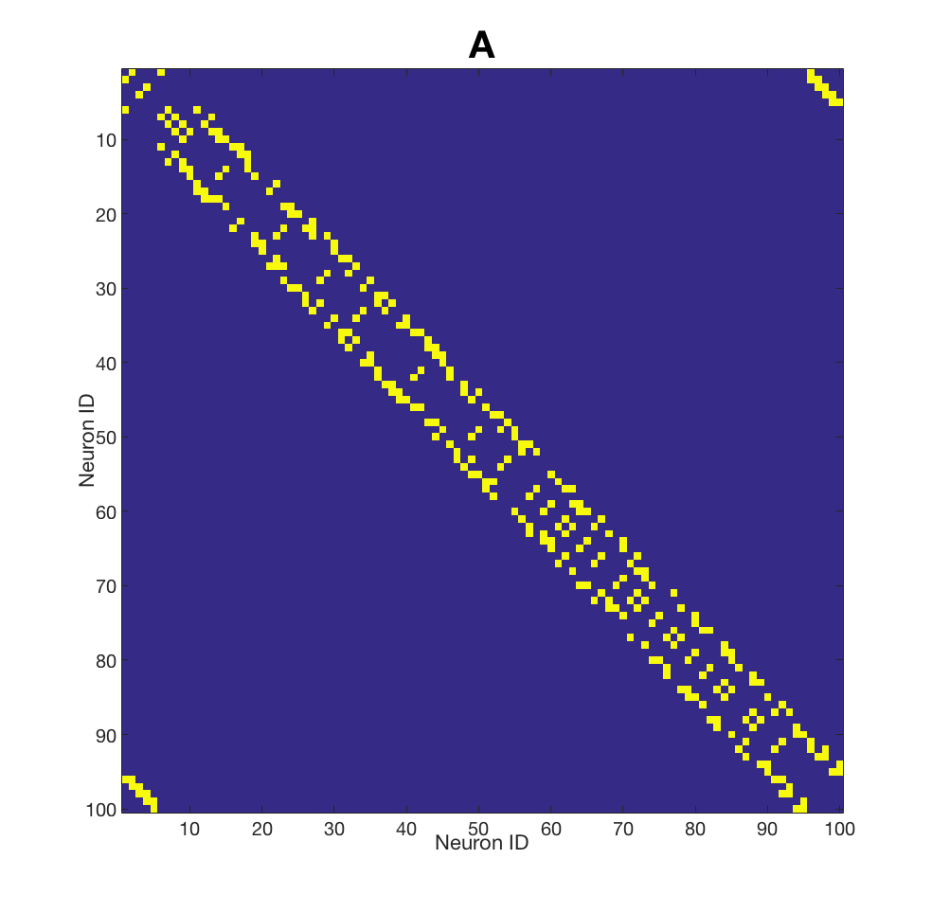

**External input**

$${if t<t_{st} then I}_{ext}=step$$

$${else I}_{ext}=0$$

**Connectivity**

N – number of neurons

sp – spikes in the spike train

**Indexes**

k – index over neurons

m – index of connected neurons

i – index over synapses

j – index over spikes

Summation over synaptic connections is organised by sparse connectivity matrix **A**

Gap-junctions are located in the same places

as synaptic connections according to matrix **A**